

How to share and embed a tutorial
Send a link, embed the video in your help center, and see who's watching.

1. Copy the share link
In the editor's share panel, copy the link. It opens a page with the video and the written steps, in your brand.
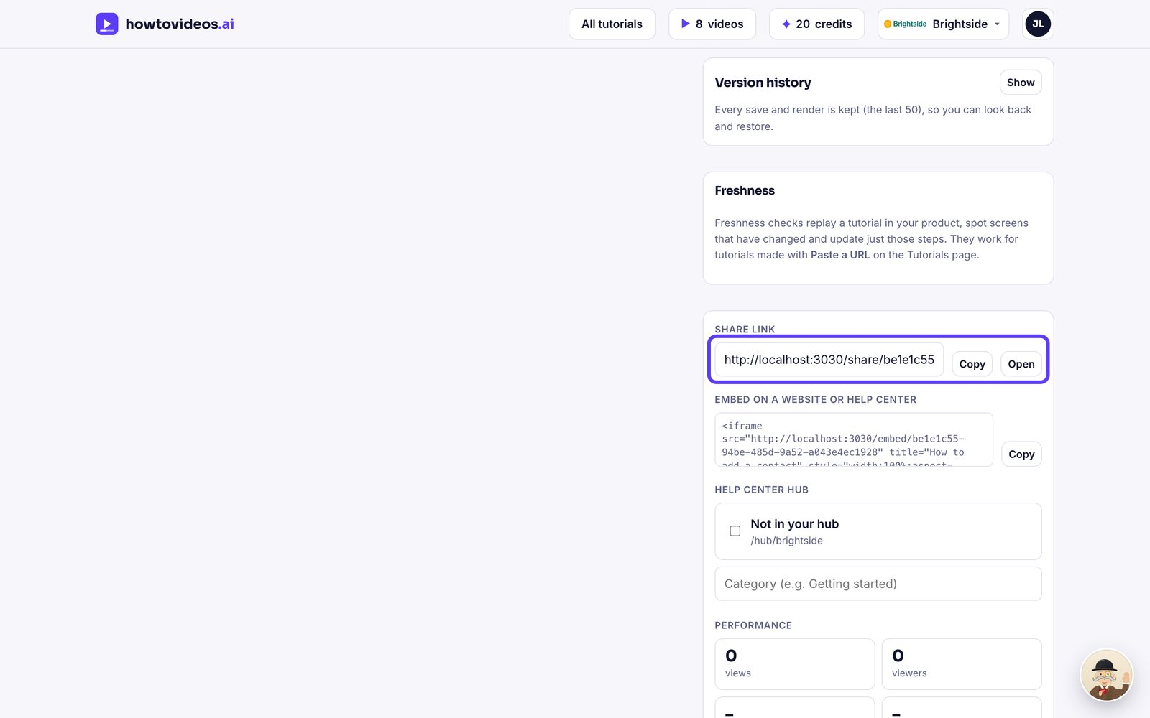

2. What viewers see
Viewers get the video, step-by-step instructions with screenshots, and PDF and Word downloads.
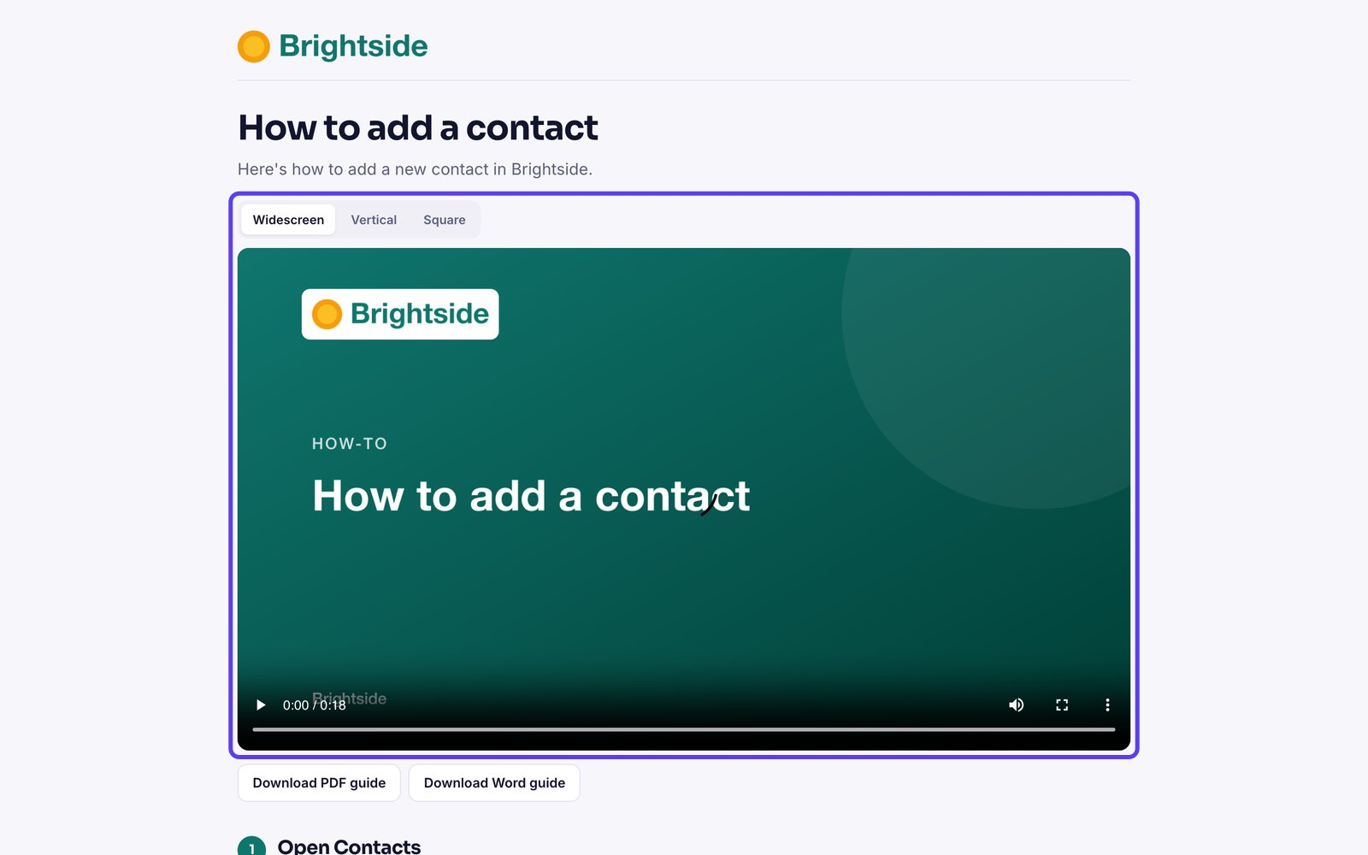

3. Embed it anywhere
Copy the embed code and paste it into your website, Zendesk, Intercom, Notion or any page that accepts HTML.
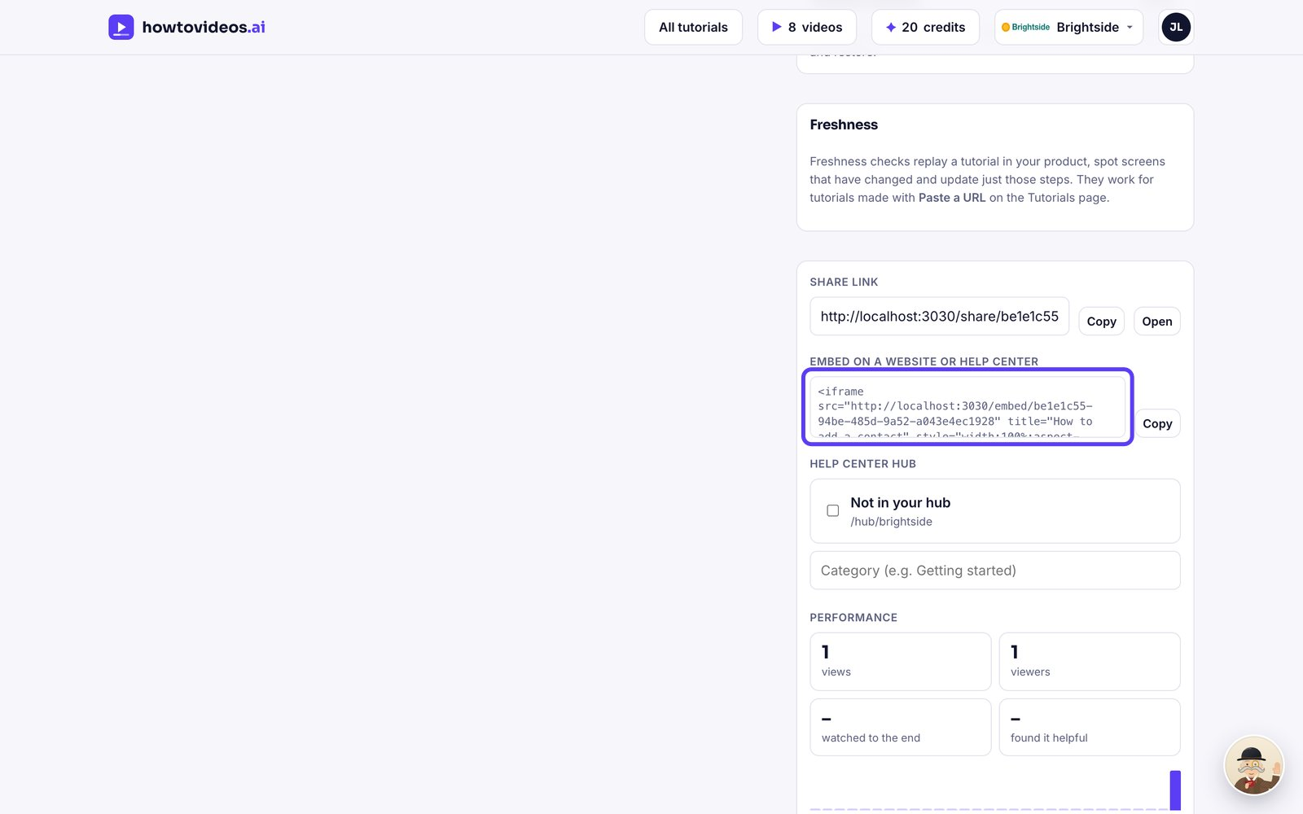

4. See how it's doing
Under Performance, see views, viewers, how many watched to the end, and how many found it helpful.
