

How to publish a help center
Give customers a branded, searchable library of your tutorials.

1. Set up your hub
In Brand and settings, find Help center hub. Choose its web address, a title and a short intro.
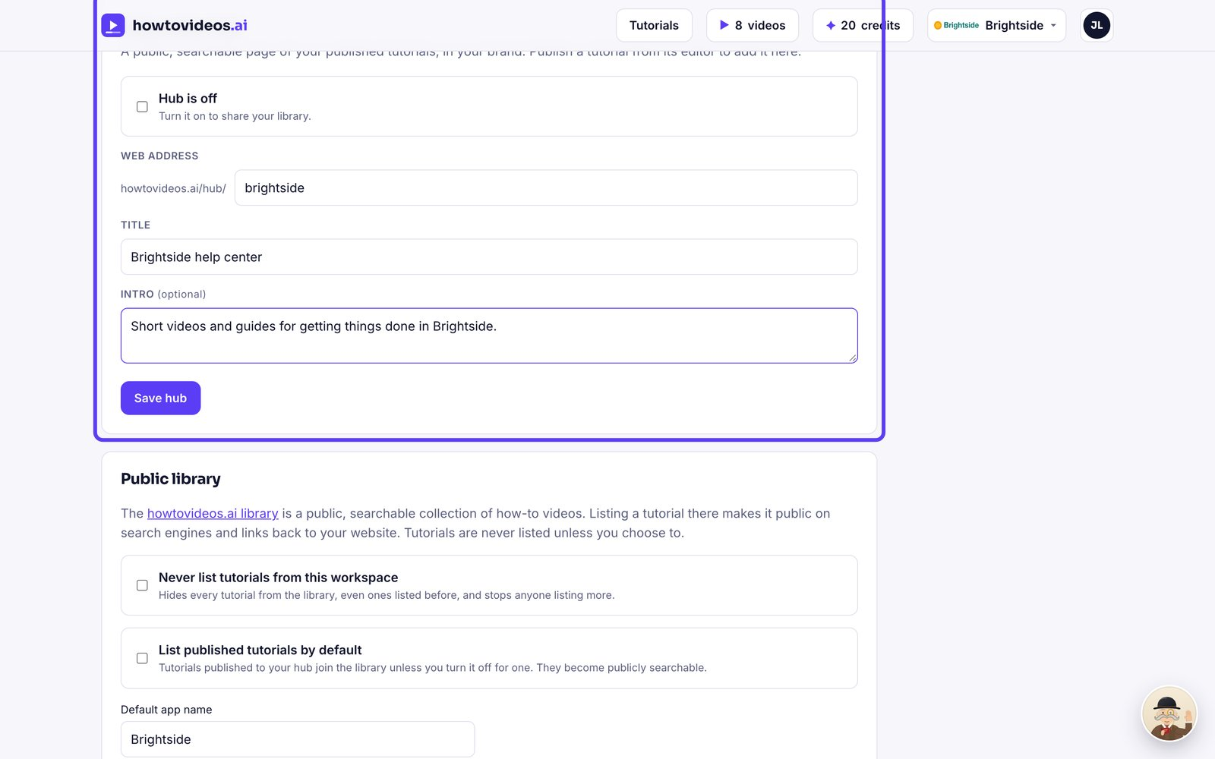

2. Turn it on
Tick the box to put your hub live.
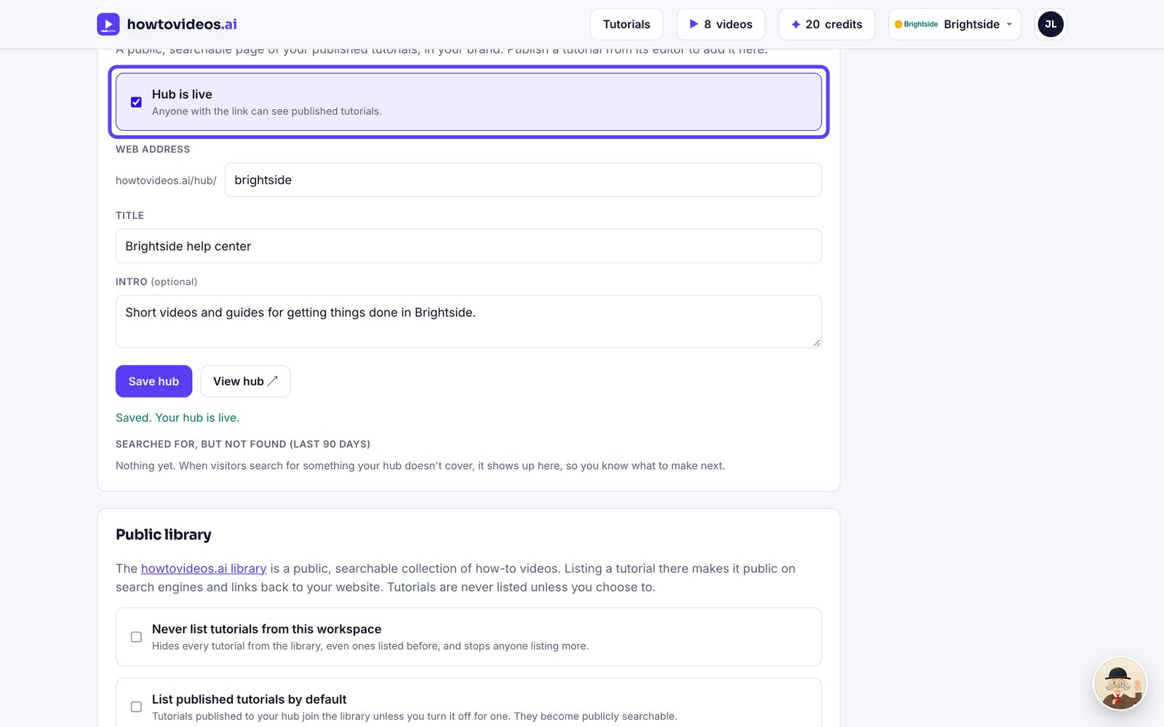

3. Publish tutorials to it
In each tutorial's share panel, tick Published to your hub and give it a category.
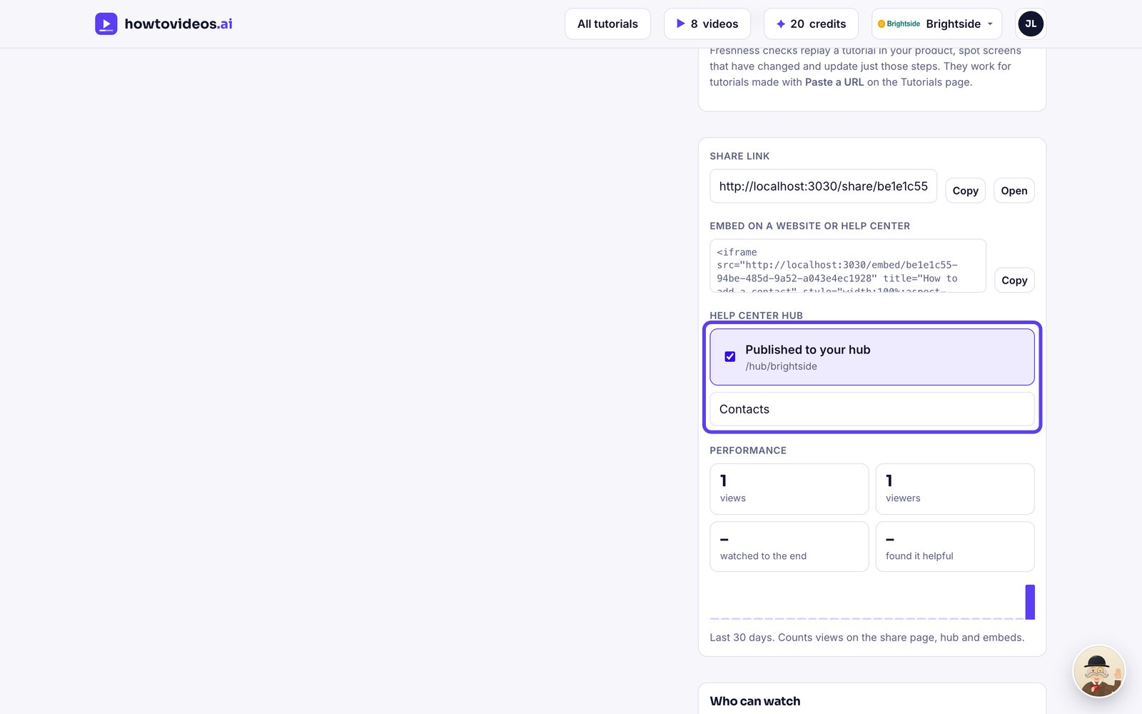

4. Your customers search and watch
Customers search your hub and open any tutorial. Searches that find nothing are listed in your settings, so you know what to make next.
