

How to make your first how-to video
Turn a screen recording into a narrated, branded how-to video and written guide.

1. Upload a screen recording
On the Tutorials page, drop a screen recording in, or choose Choose a file. MP4, MOV and WebM all work.
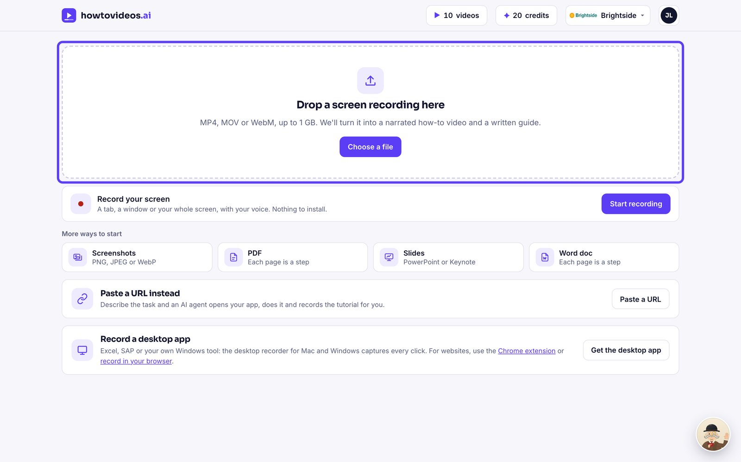

2. Let it read the recording
We find the key moments and write the steps and script for you. This usually takes under a minute.
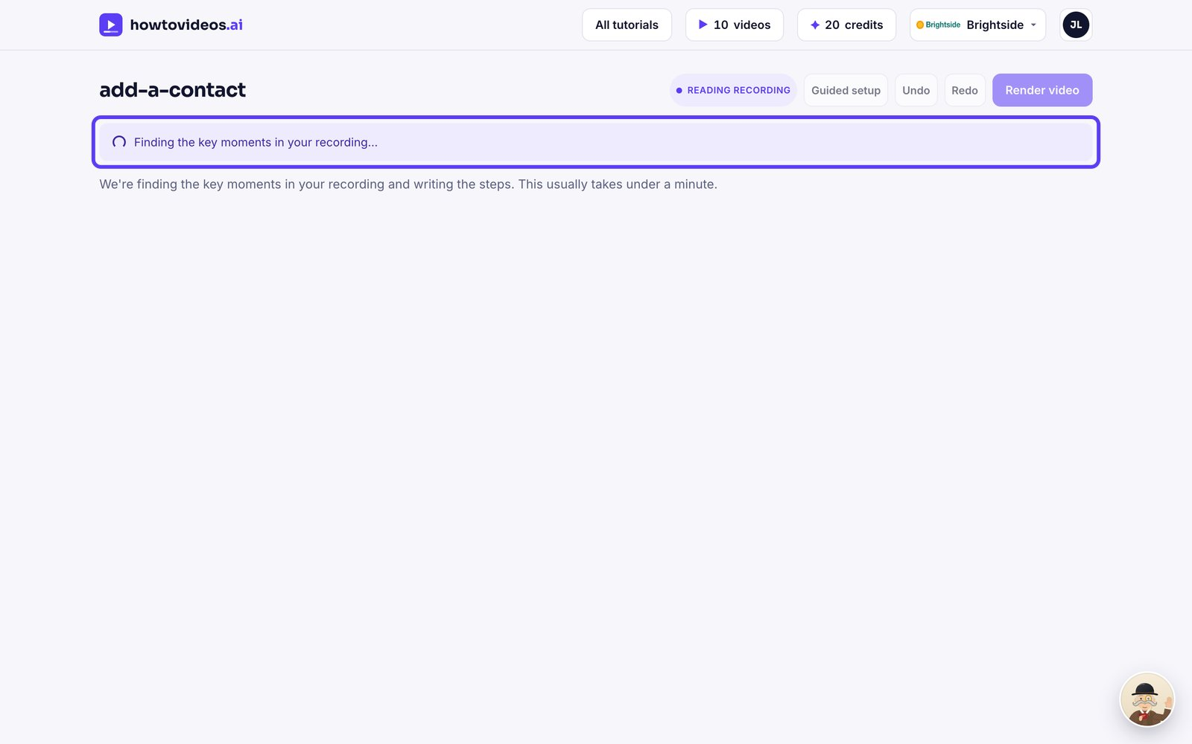

3. Choose the basics
A short guided setup opens first. Choose the video's shape, captions and cursor, or close it and set them later.
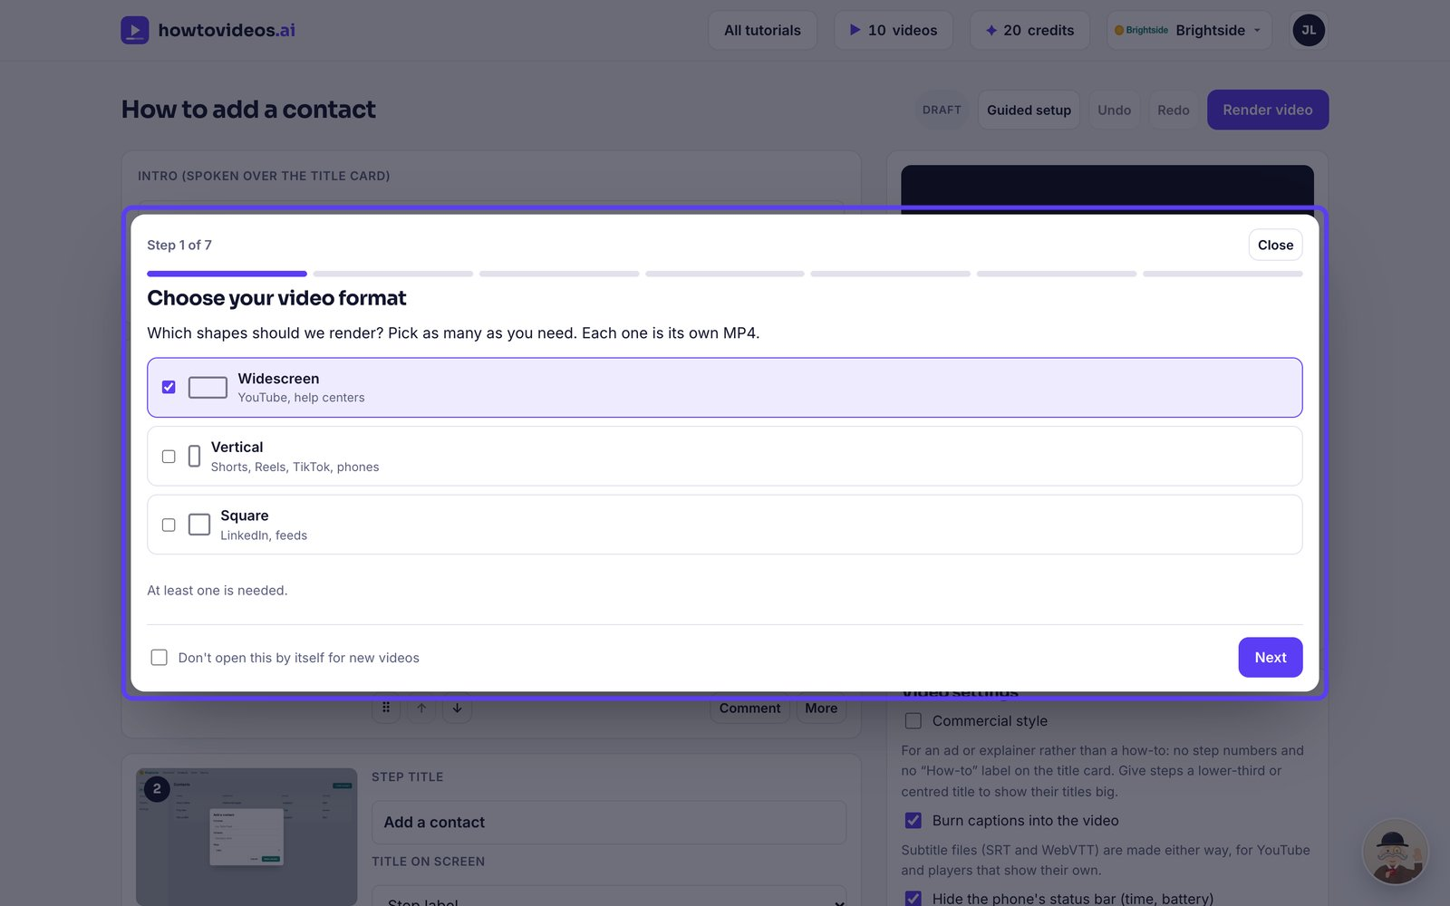

4. Check the steps
Each step has a screenshot, a title and the words the narrator will say. The highlight shows where the video zooms in.
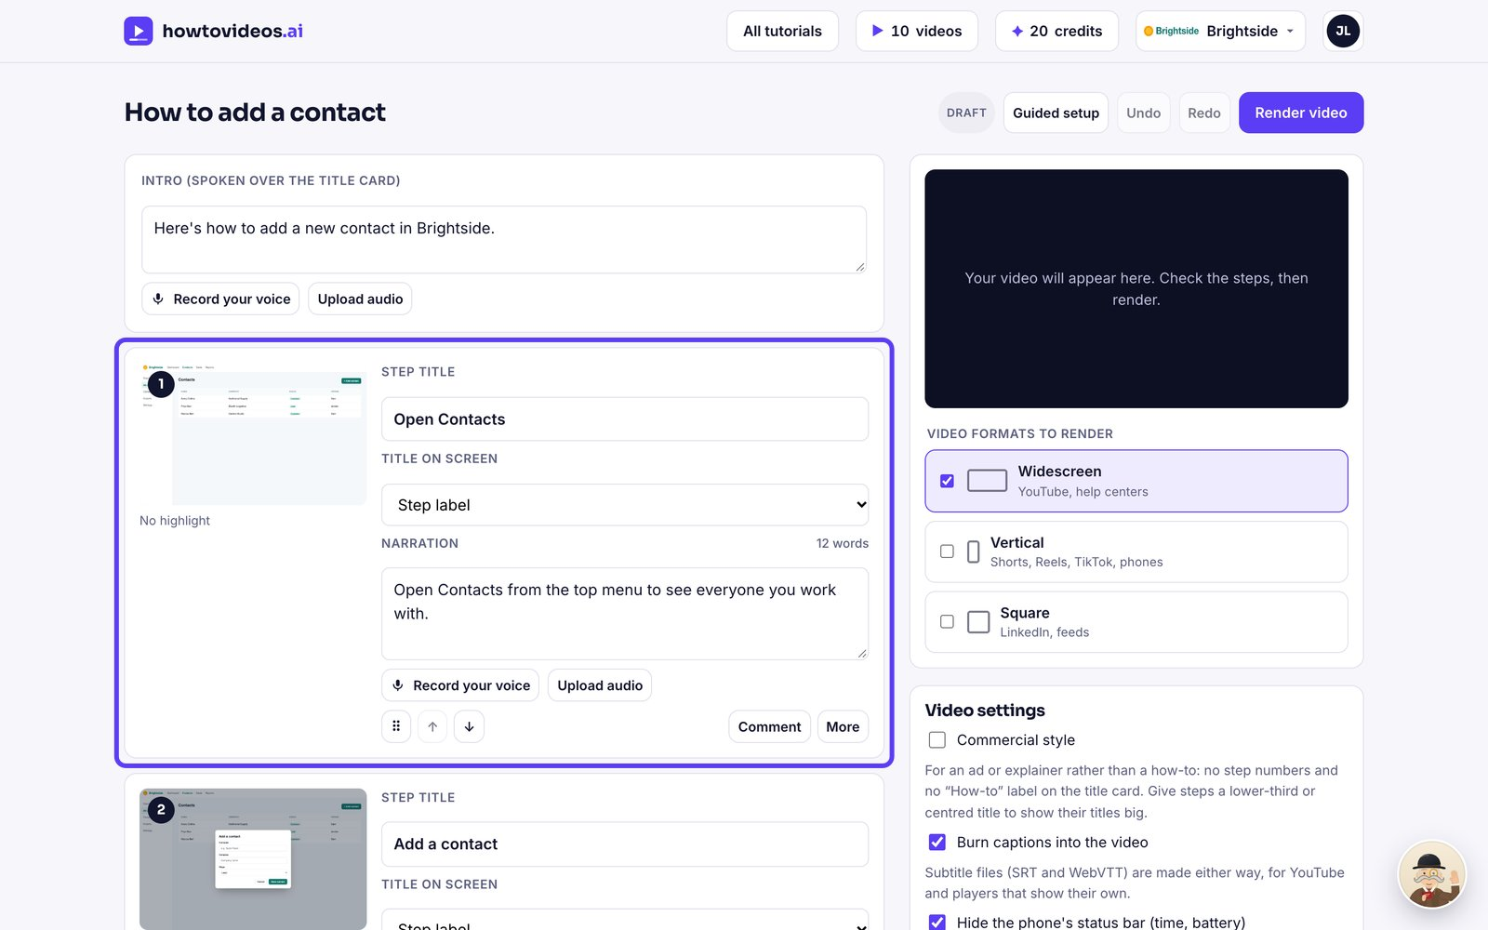

5. Render the video
When it reads well, choose Render video.
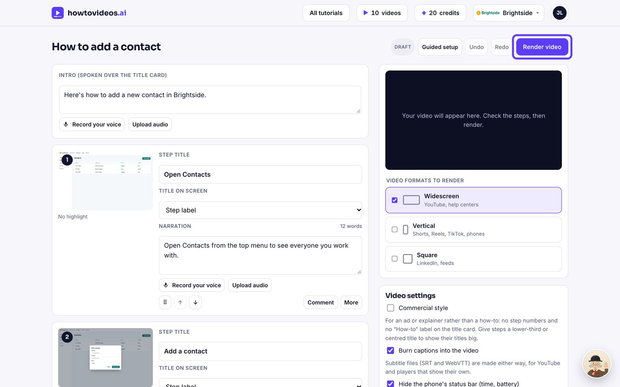

6. Watch and download
Your finished video plays right here. Download the MP4, or the written guide as a PDF, Word or Markdown file.
