

How to edit the steps and script
Change what the narrator says, rename steps, reorder them or remove one.

1. Open the tutorial
Open any tutorial from your Tutorials page to edit it.
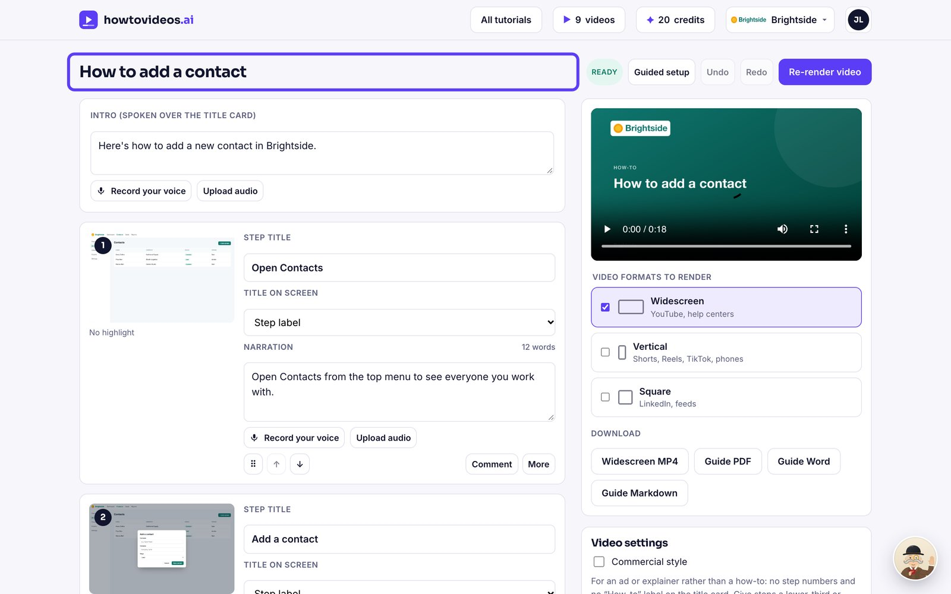

2. Change the narration
Click into a step's narration and type. This is exactly what the narrator will say.
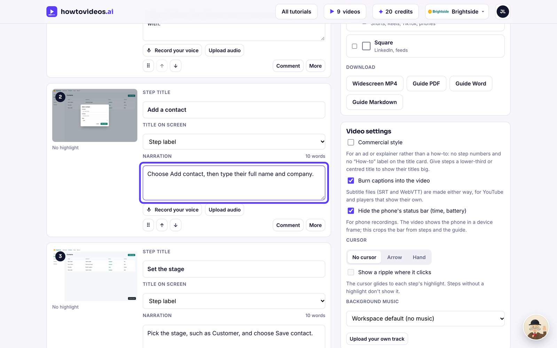

3. Reorder or remove steps
Use the arrows to move a step up or down, or Remove to take it out.
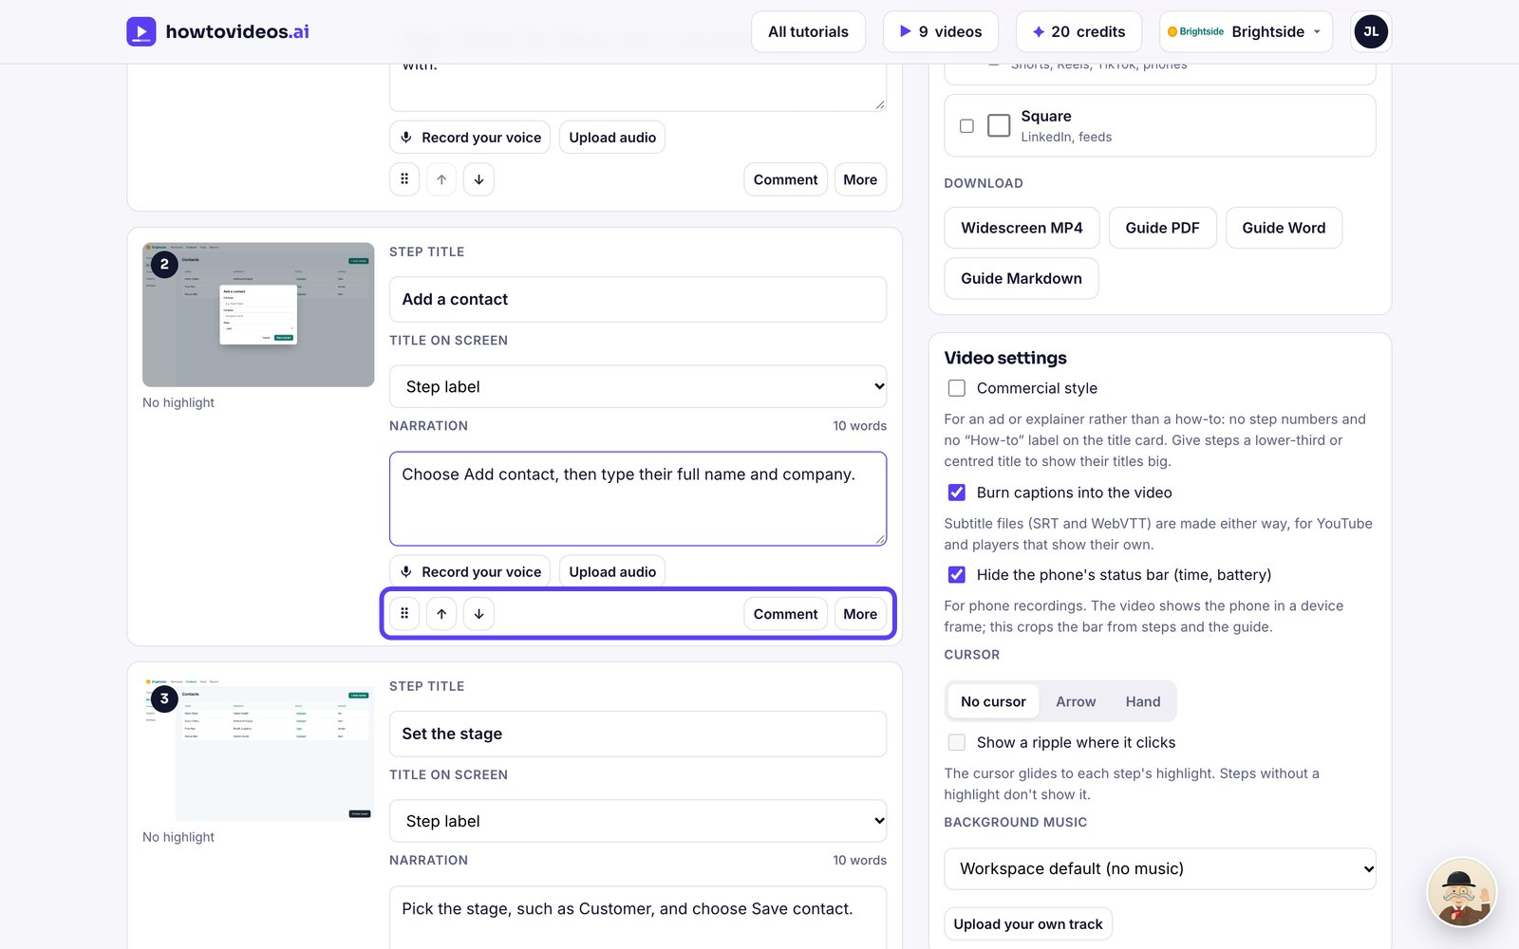

4. Save your changes
Choose Save changes. The video is marked as out of date until you render it again.
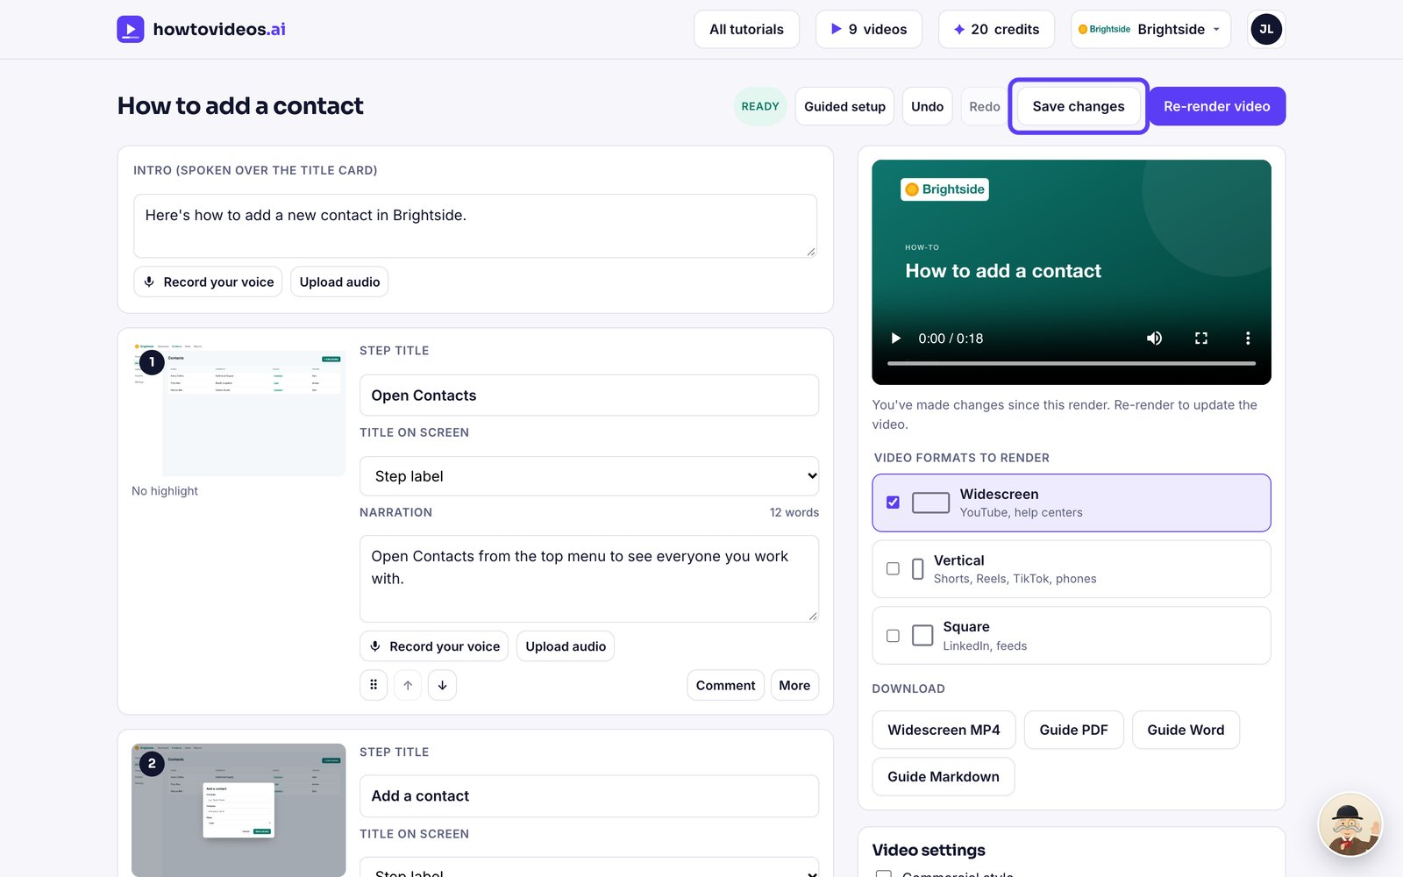

5. Render again
Choose Re-render video. Lines you didn't change keep the same voice recording, so it's quick.
