

How to set up client workspaces
For agencies: a separate brand and tutorial library for every client.

1. Choose My clients
In Brand and settings, under Who are the videos for, choose My clients.
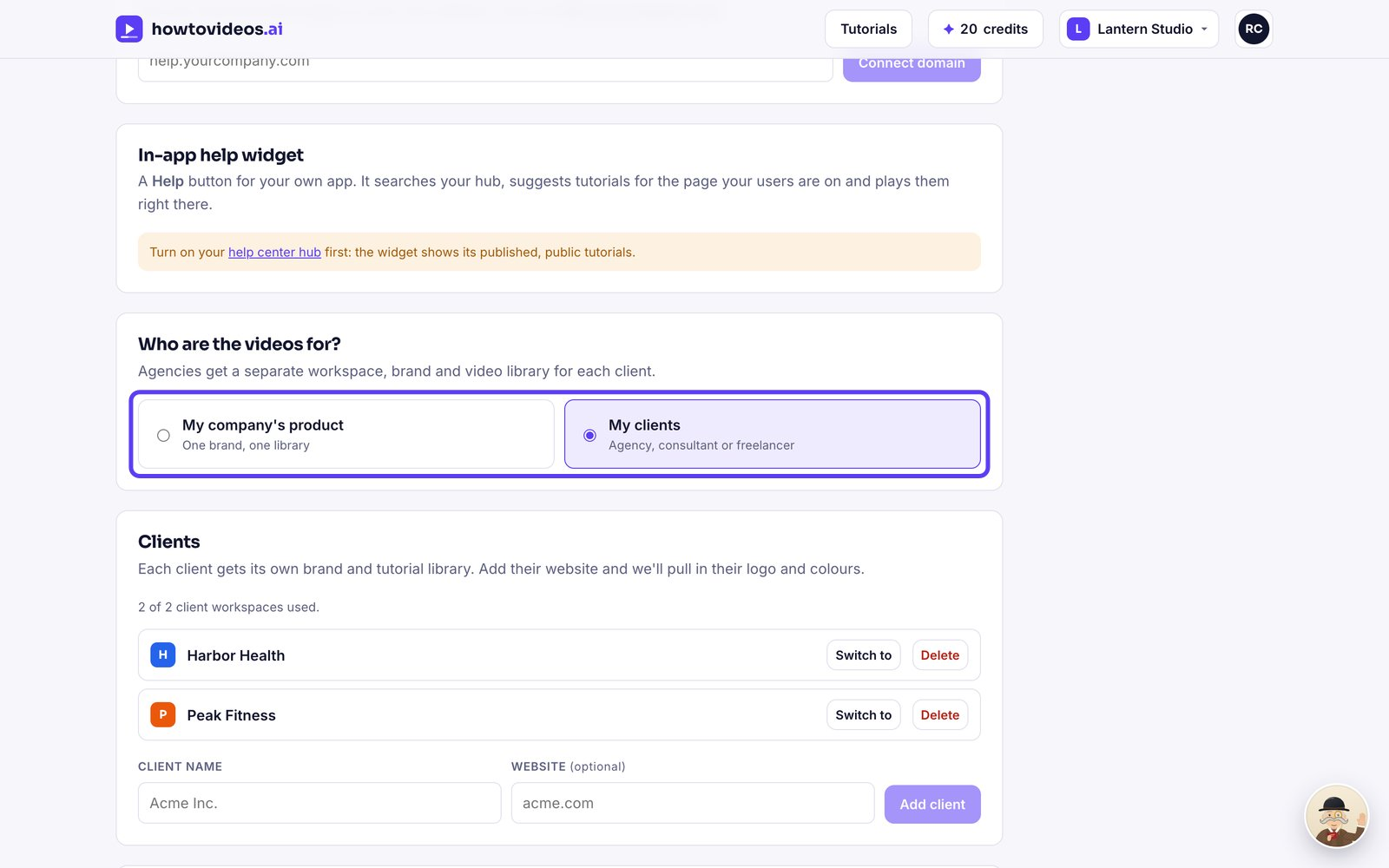

2. Add a client
Under Clients, type the client's name and website, then choose Add client. We pull in their logo and colours.
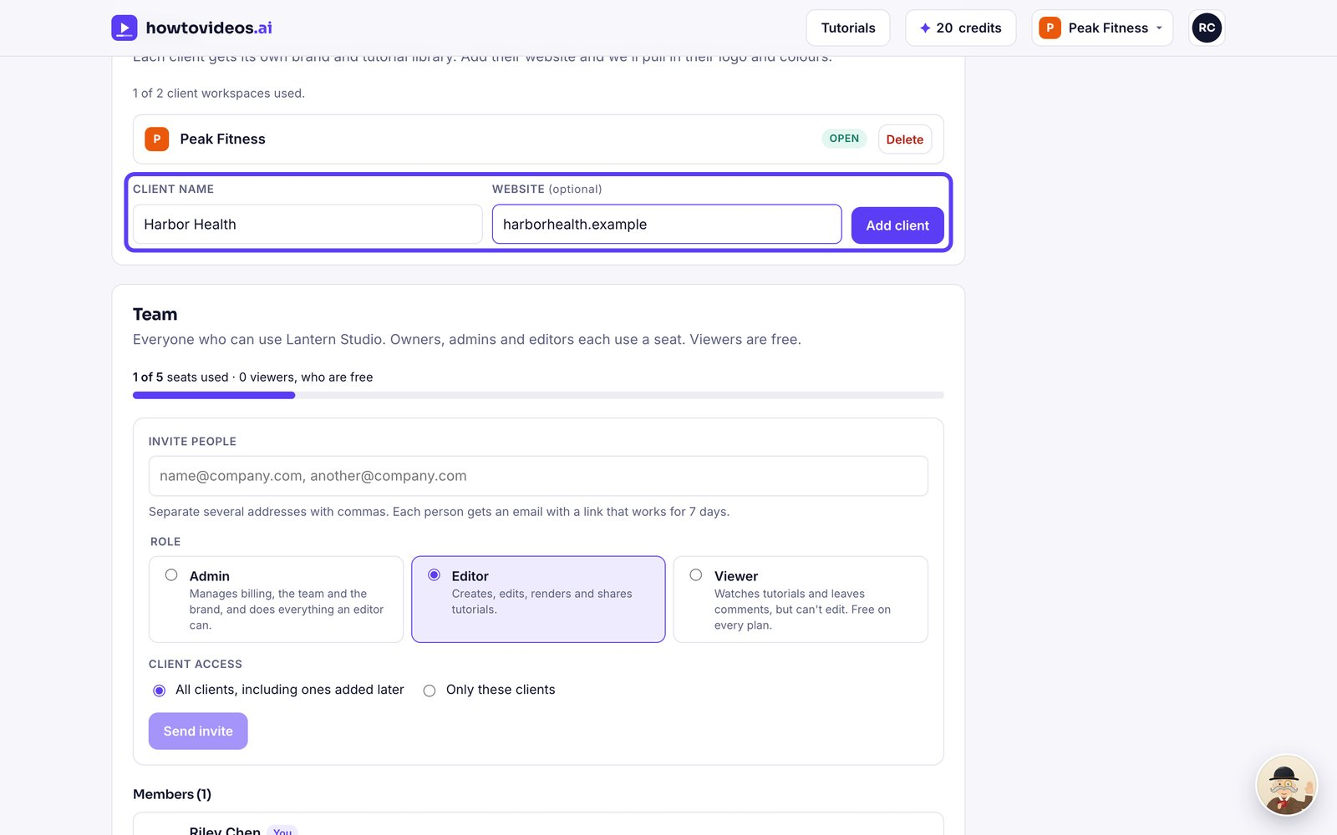

3. Switch between clients
Use the menu at the top right to switch between your agency and each client.
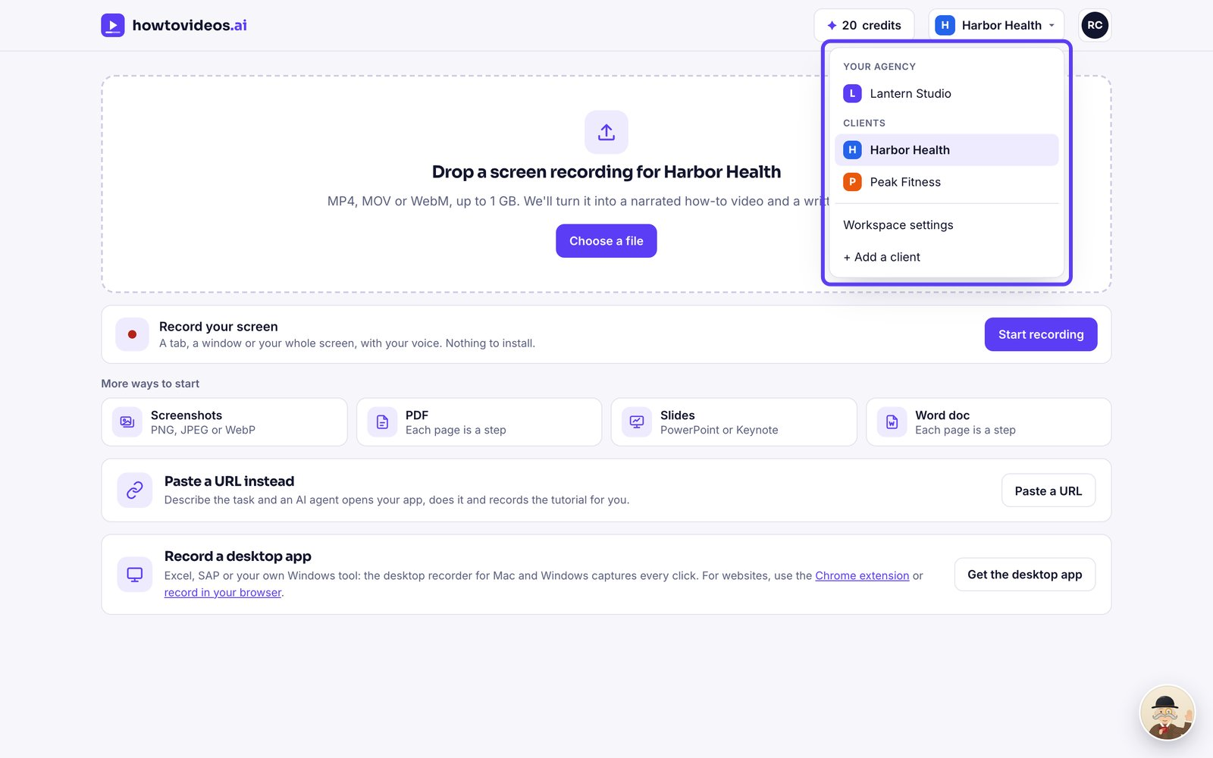

4. Work inside a client
Everything you upload now belongs to that client, with their brand on every video.
