

How to get help from Mr. Ken Doo
Ask the built-in helper anything, or have him make changes for you.

1. Open Mr. Ken Doo
Choose Mr. Ken Doo in the bottom-right corner of any page.
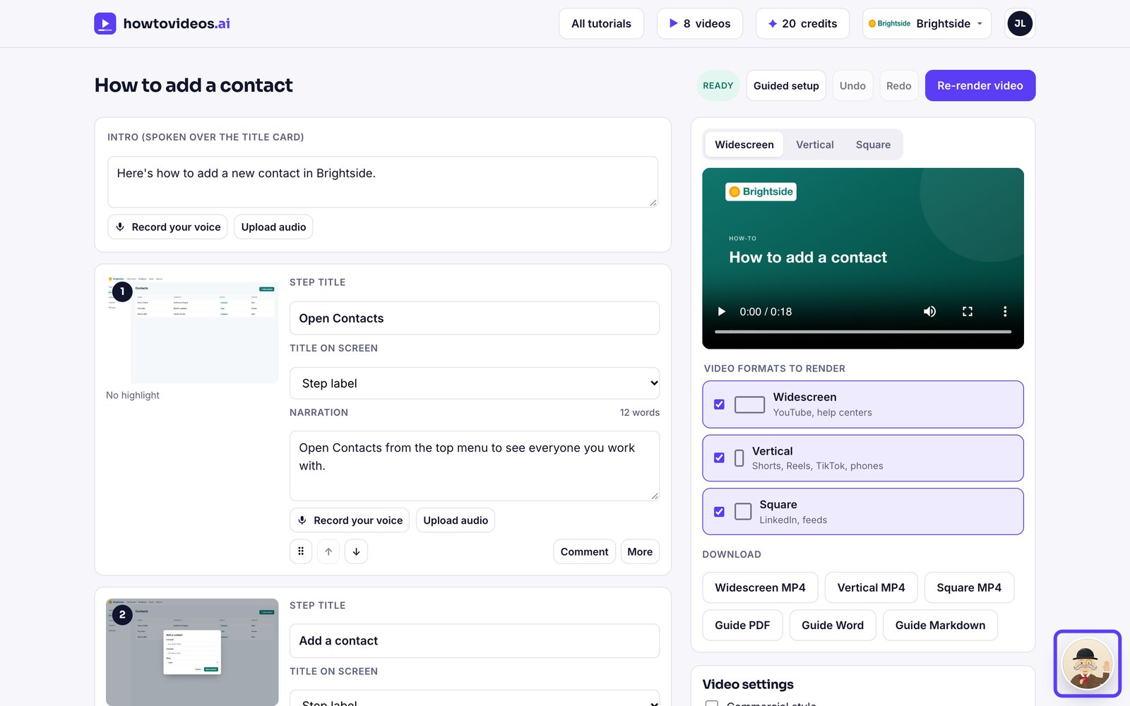

2. Pick a suggestion or ask anything
Choose a suggestion, or type your own question. On a tutorial, he can rewrite the script, change formats or render it for you.
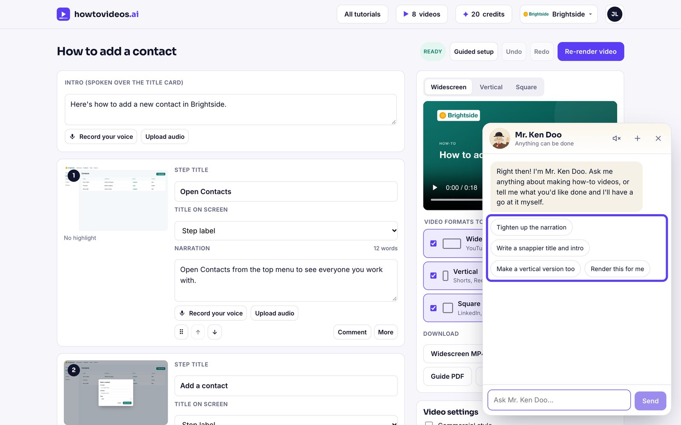

3. Hear the answers
Turn on read aloud to hear his answers spoken.
