

How to add your logo and brand colours
Put your logo and colours on every title card, highlight and share page.

1. Import from your website
Open Brand and settings, type your website and choose Import logo and colours. We find your logo and brand colours for you.
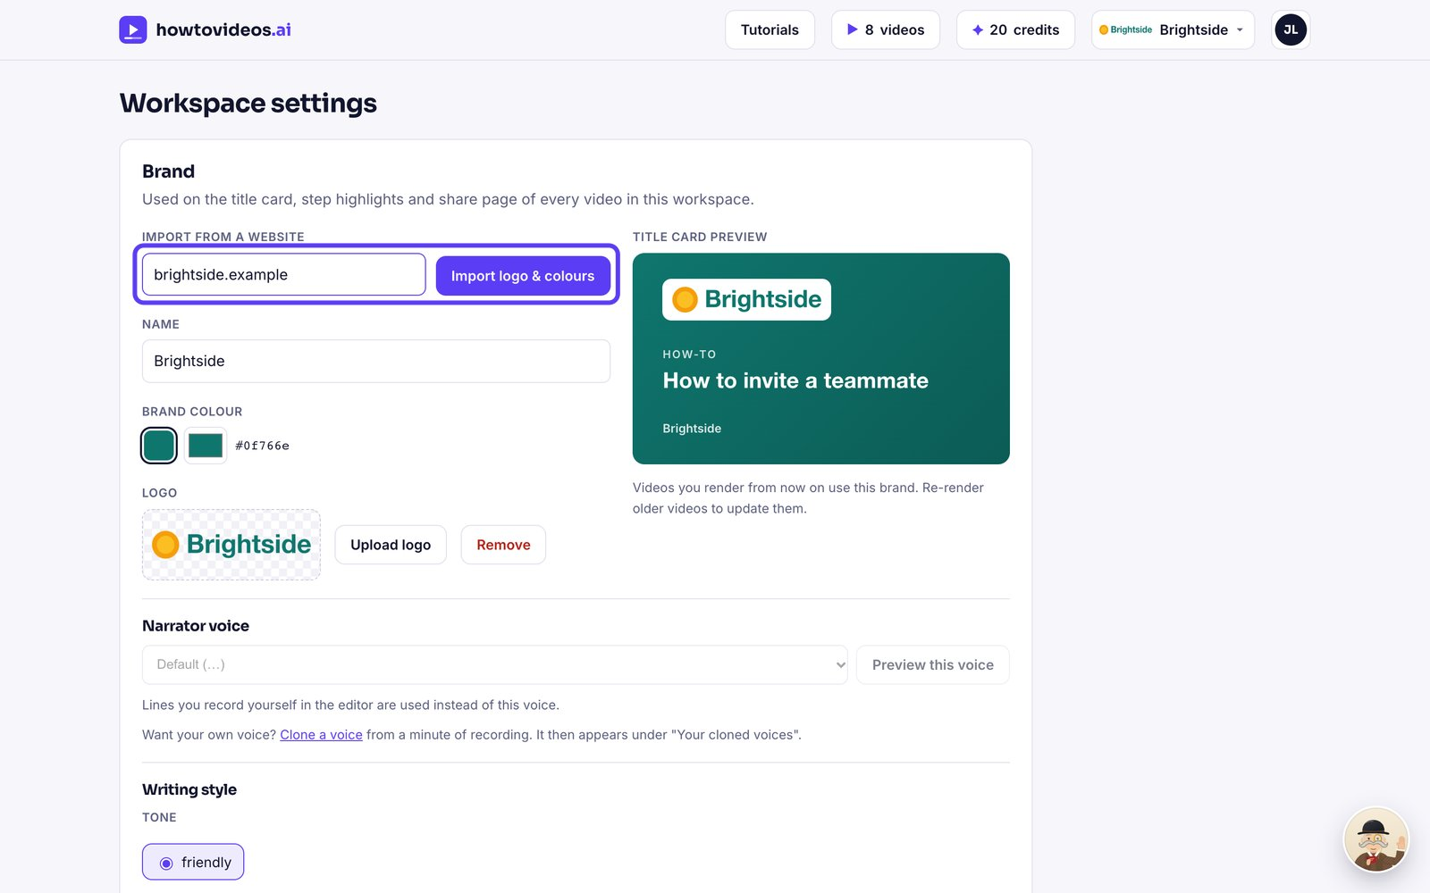

2. Pick your brand colour
Choose one of the colours we found, or pick any colour you like.
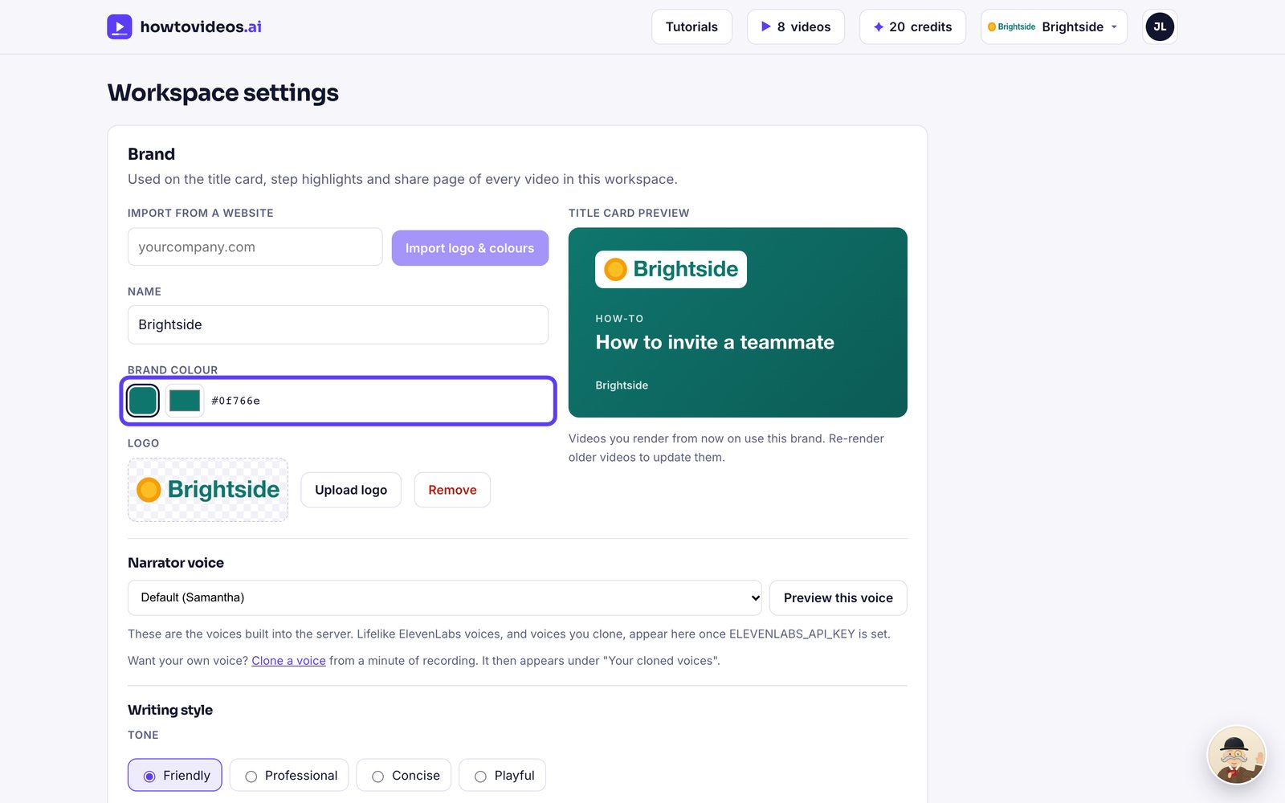

3. Upload a logo if you'd rather
Prefer a different logo? Choose Upload logo. PNG, JPEG, SVG and WebP all work.
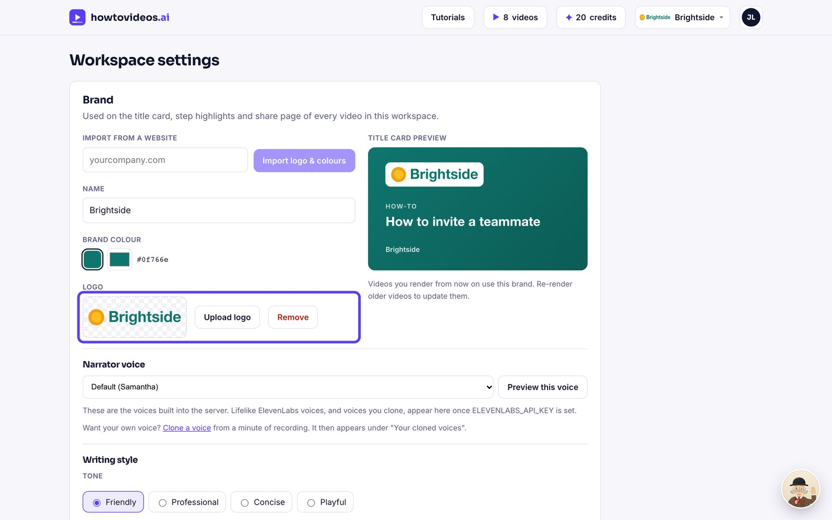

4. Check the preview
The preview shows how your title cards will look. New videos use your brand automatically.
