

How to change your password
Update your name or password, and sign out of other devices.

1. Open your account
Choose your initials at the top right, then Your account.
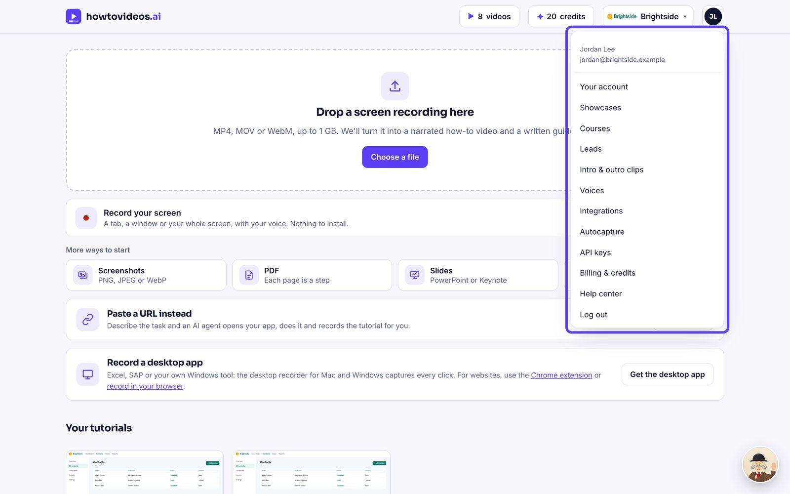

2. Change your password
Type your current password and a new one of at least 10 characters, then choose Change password. Other devices are signed out.
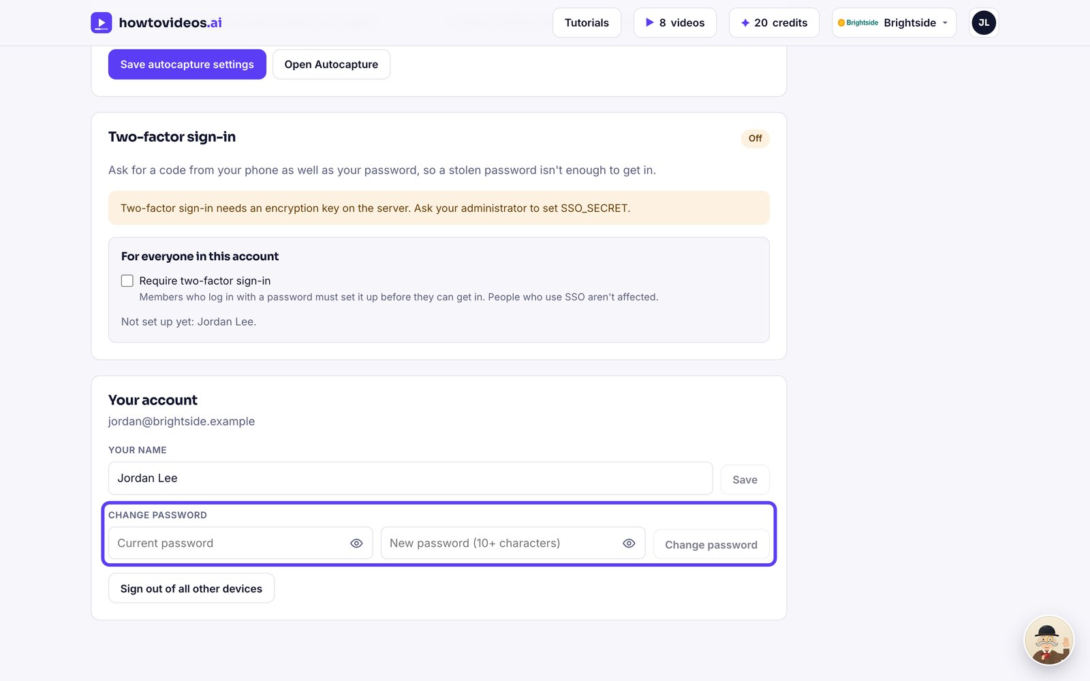

3. Sign out everywhere else
Lost a laptop? Choose Sign out of all other devices.
